**Task of c programing**

* **Activity number1:**

**.**tools needed for running c program

* **Dev c++**
* **Visual basic**
* **Code lite**
* **Code block**

**Acording to the above list of tools i choose only one:**

* 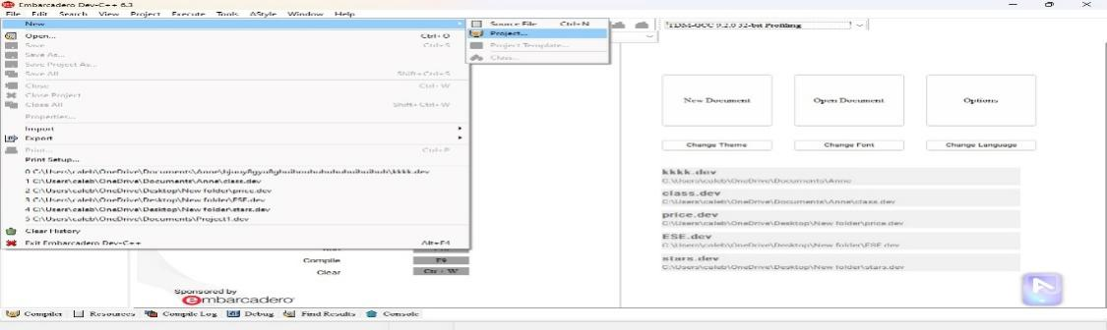**. Dev c++**

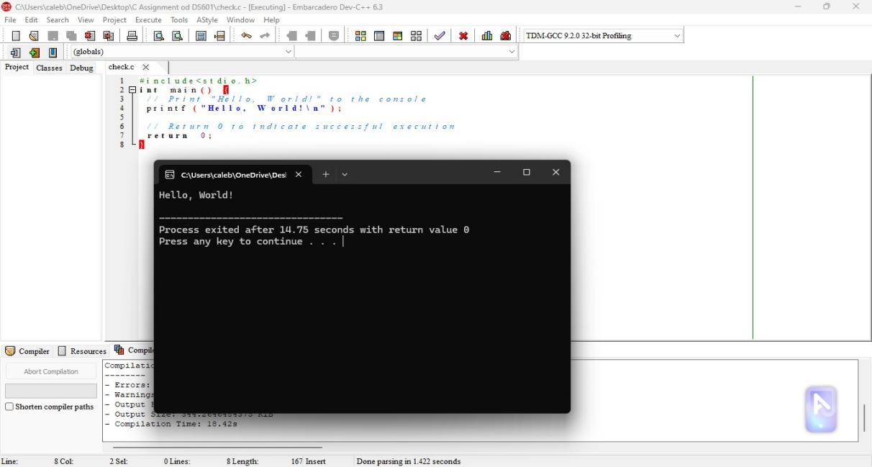

**this is how i get out put in dev c++**

**Q2,what is github:it is web based interface that uses git,open source version control software that let multiple people to make separate change web page at the some time..**

***Steps of using/runing github***

***.***step:Go to <https://github.com/join>

***.***Enteryour personal detail( create username,password)

***.***click verify to start verification(puzle) which show us you are not robot ,you will see verified acount(created acount)

***.***click the green buton and create acount

***.***verify your email by entering codes



